**How does a call take place in mobile?**

Like internet, mobile is the best way to keep in touch with people wherever they belong on earth. Moreover, unlike computer it is portable and can be carried wherever we want, due to its small size. Many of new generation mobile also provide internet facility. Mobile may be regarded as one of the finest inventions of the century. But do we know how it works? Let’s get started to see how it works.

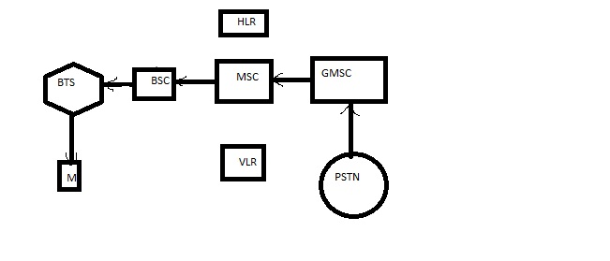

**Fig: Interaction between GSM Subsystems**

In the figure below

M->Mobile Device

BTS->Base Trans Receiver (Local Control Tower)

BSC->Base Station Controller (Area Control Tower)

MSC->Main Station Controller (City/Town Control Tower)

HLR->Home Location Register (Has registries for all mobile devices in that MSC)

VLR->Visitor Location Register (Contains temporary copy of some information of mobile device necessary for call control, one per MSC)

GMSC->Gateway MSC (Link between different MSC and landline devices)

PSTN->Public Switched Telephone Network (Links to landline devices)

The figure shows the interaction between various hardware devices that are present:

Communication takes place between the devices and other subsystems in the form of electromagnetic waves that are not seen to the naked eye.

* Now, when a mobile makes a call to other mobile device, electromagnetic waves travel to the BSC and to BTS and to MSC sending the dialed number requesting the service.
* MSC checks with VLR if the Mobile is allowed for the requested service. If so, MSC asks BTS to allocate resources (frequency) for the call.
* If call is allowed, MSC routes the call to the GMSC
* GMSC routes the call to Local Exchange (if the number is of landline device) of the called user via PSTN.
* The Local Exchange applies the ringing to the called terminal.
* Answer back is sent from the called terminal to LE.
* Answer back signal is routed back to MS through the serving MSC, which completes the speech path to Mobile device.
* Similarly, if the number is of mobile device, it passes through the GMSC to other MSC where the mobile number called is located.
* When the call is terminated, the resources are returned back to the MSC.